Git troubleshoot

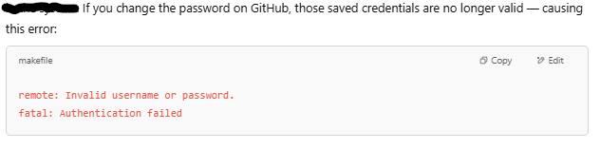

Ways to fix:

Use Personal Access Token (PAT)

* 1. Create a New Personal Access Token
* Go to: <https://github.com/settings/tokens>
* Click **"Generate new token (classic)"**
* Select scopes:
  + ✅ repo (for full control of private/public repos)
* Set expiration time (choose what suits you)
* Click **Generate Token**
* Copy the token (you won’t see it again!)
  1. Update Token in Local Git
     1. Update credentials via command line (next push)

git config --global credential.helper store

git push origin main

It will now ask:

**Username** → your GitHub username

**Password** → paste the **PAT** (not your GitHub password)

* + 1. Delete old credentials (Windows)

Search **"Credential Manager"** in Start menu

Go to **Windows Credentials**

Look for entry like git:https://github.com

Click **Remove**

Now push again (git push) — it will ask for credentials again (use token as password)